Execution of POC in
eVISION



Authors: | Phani Krishna P.
Reviewer:
Date:
Document Version Number:

Document History:
Version | AMENDMENT Date | Amendment Description
1.0

Table of Contents
1.0 INTRODUCTION 3
1.1 Purpose of the document 3
1.2 Scope 3
1.3 Intended Audience 3
2.0 DEFINITIONS 3
3.0 Pre-requisites 3
4.0 Execution 4
4.1 Creation of Web Pages using Page Layout Designer 4
4.1.1 Login Page 4
4.1.2 Operations Page (Name - Your choice) 6
4.1.3 Arithmetic Page (Name - Your choice) 7
4.2 Creation of a Page Link 8
4.3 Linking the Web Pages using Page Links in Page Flow Designer 10
4.4 Creation of a Connectivity Map 16
4.5 Adding a New eVISION external system in the environment 18
4.6 Managing login user in the integration server of the logical host 19
4.7 Creation of Deployment Profile 22
4.8 Executing the Web Page 22
4.9 Output Screen Shots 22

INTRODUCTION

1.1 Purpose of the document
The purpose of this document is to get familiarize with the eVISION core product of JCAPS suite.

Scope
This document explains how to use eVision Studio to create and deploy user interfaces for composite applications.
The scope of this document is limited to implementing a scenario in eVISION.

Intended Audience
This document is intended for experienced JCAPS consultants who need to create and deploy user interfaces for composite applications.

DEFINITIONS
Term | Use
Page Layout Designer | Used to create web pages with pre-built  GUI objects.
Page Flow Designer | Used to manage the web pages within a composite  Application.
Page Link | Used to create links to web pages and pass  parameters from one page to another.
Page Flow Engine | Orchestrates the system responses to the execution of web page component code.

Pre-requisites
- Successful Installation of eVISION.sar and eVISIONDocs.sar (optional) in repository.

Execution
The scenario followed for eVISION implementation is as follows:
- Login Page ( If successful, directs to next web page )
- A Web Page containing two input text fileds and a submit button.
- A Web Page displaying all the results of the arithmetic operations of the input provided.

Create a New Project under the repository for this scenario. The Project is named as prjVISION in this document.

Creation of Web Pages using Page Layout Designer

Login Page
- Right click on the project prjVISION and select ‘NEW’ and choose ‘Page Layout’.
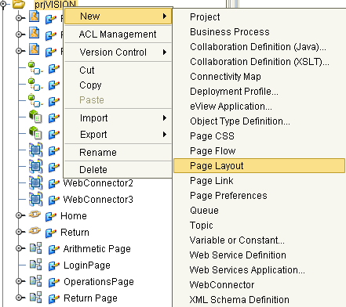

- Select the ‘Login’ Page from the option available and rename it to LoginPage and save the Page.
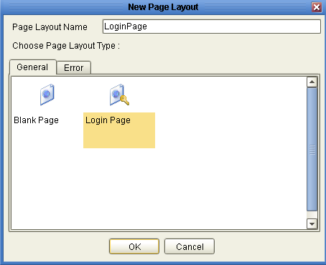
- Login page will be displayed as follows.
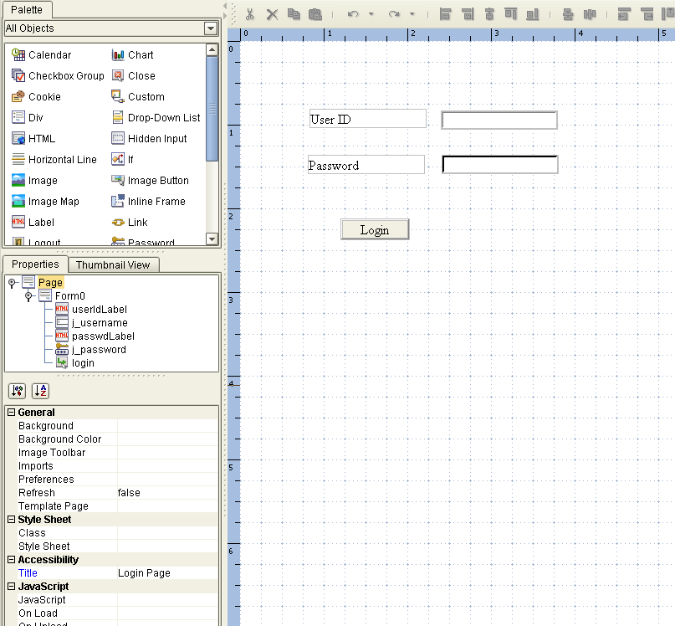

Operations Page (Name - Your choice)
- Again right click on the project prjVISION and select ‘NEW’ and choose ‘Page Layout’.
- Select Blank Page this time and rename it to ‘Operations Page’ ( You can choose any name )
- This Web Page should contain 2 labels,2 text input fields and a submit button.
- Here in this scenario , I have used a ‘DIV’ object from the Palette to divide the page into logical section . ( Optional Step )
- As per requirement, drag 2 labels (2 times the label object) on the canvas from the Palette and rename them accordingly.
- Rename first label as ‘Enter First Number’ and second label as ‘Enter Second Number’ ( You can choose any name )
- Besides these 2 label fields, drag 2 text input fields (2 times the text input field) from the Palette onto the canvas respectively and name those text fields to your choice ( Here in this scenario specified as ‘Text_Input1’ and ‘Text_Input2’)
- Drag a submit button from the Palette onto the canvas and save the Page.
The final Web page would be like the below one
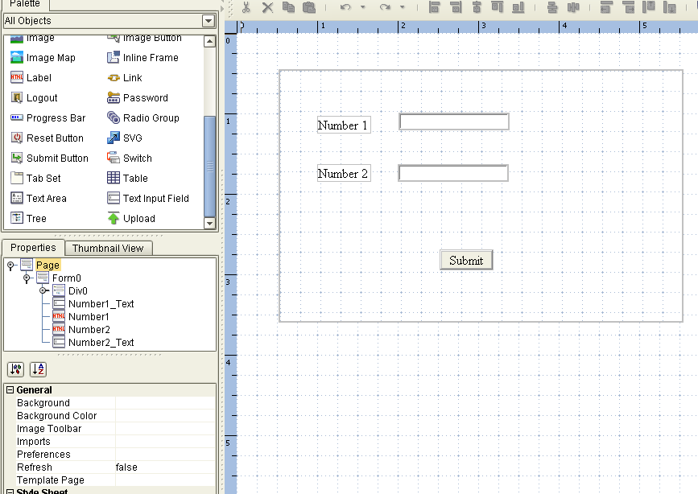

Arithmetic Page (Name - Your choice)
- Again right click on the project prjVISION and select ‘NEW’ and choose ‘Page Layout’.
- Select Blank Page this time and rename it to ‘Arithmetic Page’ (You can choose any name).
- This Web Page will contain 4 labels and 4 text input fields.
- As per requirement drag 4 labels (4 times the label object) from the Palette onto the canvas and rename them as ‘Addition’, ‘Subtraction’, ‘Multiply’ and ‘Division’ accordingly.
- Drag 4 text input fields (4 times the text input field) from the Palette onto the canvas. Place them in front of these 4 labels accordingly and name them as ‘AddResult’,’SubResult’,’MultiResult’ and ‘DivResult’ (Your choice)
The final Web page would be like the below one
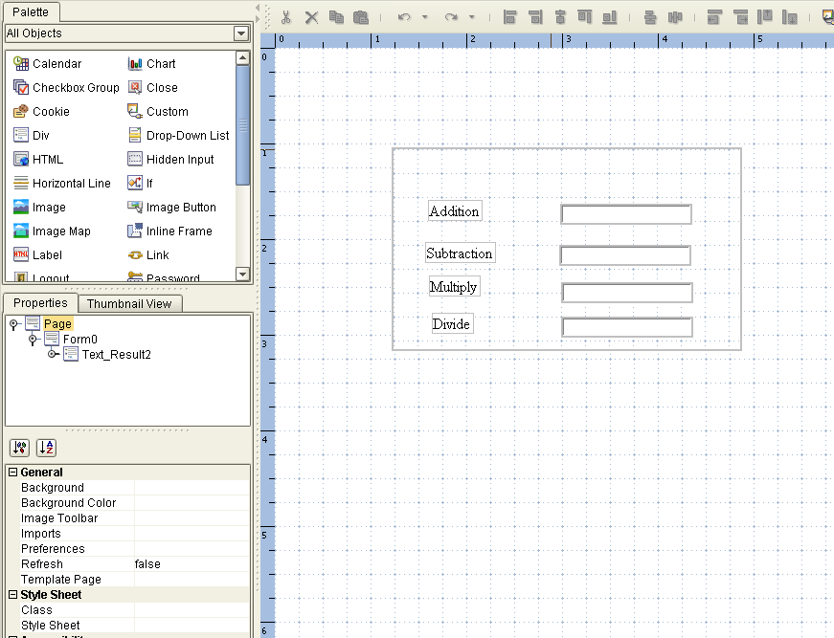

Creation of a Page Link
- Right click on the project and select ‘NEW’ and choose ‘Page Link’ option.

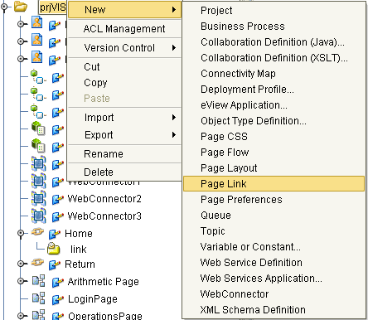

- Rename the Page link to a new name like ‘Home’ (Your choice).
- There will be a check box down to the Page Link Name as ‘ Designate as home page ‘ . Please select that check box.
The final Page Link configuration would be like the below one
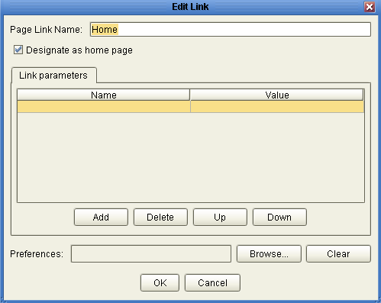

Linking the Web Pages using Page Links in Page Flow Designer
- Right click on the project and select ‘NEW’ and choose ‘Page Flow’ option and name it to ‘PFVision’ . ( Your choice)
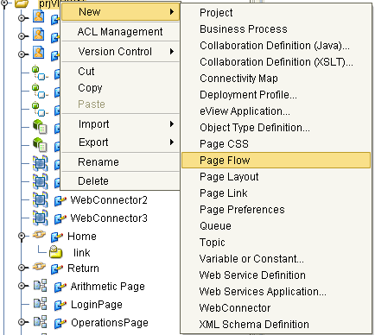

- Select the ‘Event Based Decision’ option from the Branching activities button in the Process Flow toolbar and drag it onto the canvas Please see the below figure for the same.
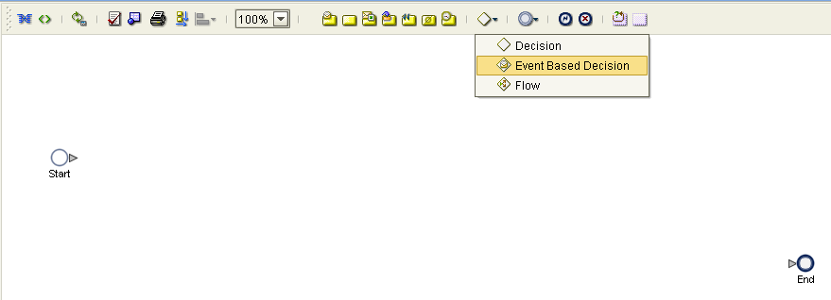

- Once dragged onto the canvas,connect it to the ‘Start’ button.
- Select the ‘Business Rule’ button from the toolbar and drag it onto the canvas.
- Now connect the ‘Event Based Decision’ to the ‘Business rule’. Please see the below figure.
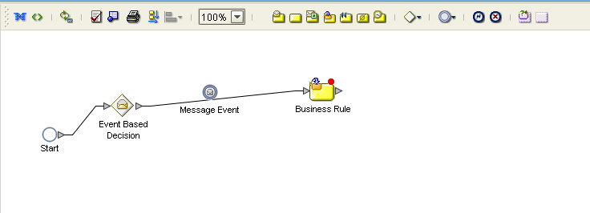

- Now from the Enterprise Explorer window, select the ‘Link’ service of the ‘Home’ Page Link, drag it and map(drop) it to the ‘Message Event’ ( between Event Based Decision and Business Rule ) onto the canvas.
Observe the ‘Message Event’ will be changed to ‘Home.link’ in name.
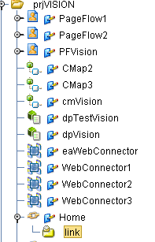

- Select the ‘Home.link’ and click the ‘Show Property Sheet’ button in the tool bar. You will see the list of properties updated automatically.
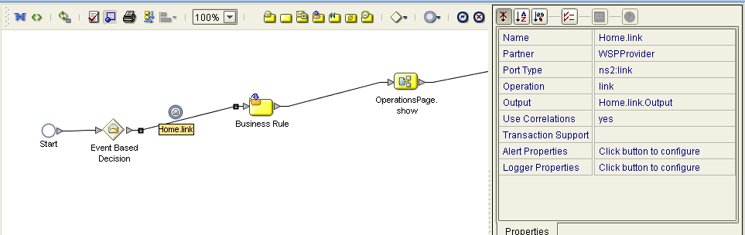

- Now from the Enterprise Explorer window, select the ‘show’ service of the ‘OperationsPage’ Page Layout, drag it onto the canvas besides the business rule and link them.
- Select the ‘Business Rule’ before the OperationsPage, and then click the ‘Display Business Rule Designer’ on the Page Flow tool bar. (First button on the top of the tool bar).
- Now map the ‘Input ‘from Home.Link.Output to the ‘title’ field of OperationsPage.show.Input and save it.

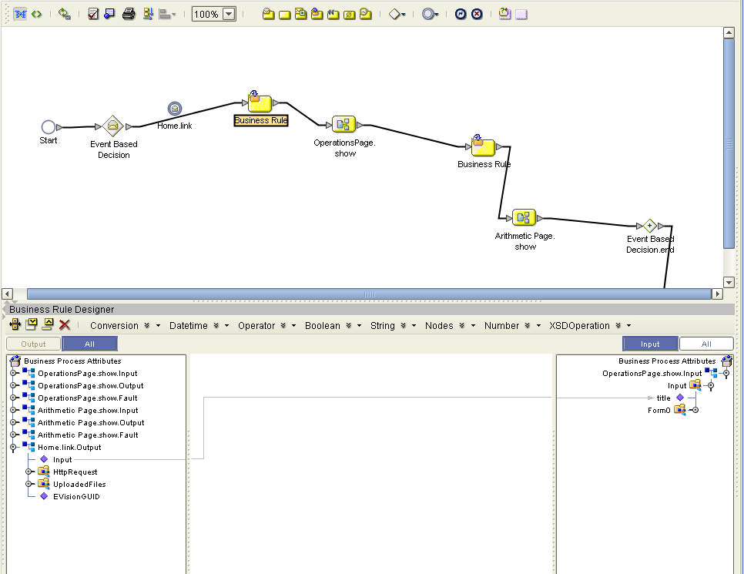

- Now drag another ‘Business Rule’ from the tool bar and drop it onto the right side of the Operations. show button on the canvas and link them.
- Now from the Enterprise Explorer window, select the ‘show’ service of the ‘ArithmeticPage’ Page Layout, drag it onto the canvas besides the new business rule created in the above step and link them.
- Select the ‘Business Rule’ ( in between OperationsPage.show & ArithmeticPage.show services )before the OperationsPage, and then click the ‘Display Business Rule Designer’ on the Page Flow tool bar. ( first button on the top of the tool bar ).
- Now in the Business Rule Designer, click the Operator drop down list and select the 4 arithmetic operators ( + ,- ,*, / ) and drag them to the middle of the Business Rule Designer.
- Now map the two input text fields of OperationsPage.show.Output to the two input fields for all these operators respectively. Also map the return values of all the operators to the Text field values respectively in ArtimeticPage.show.Input and save it.

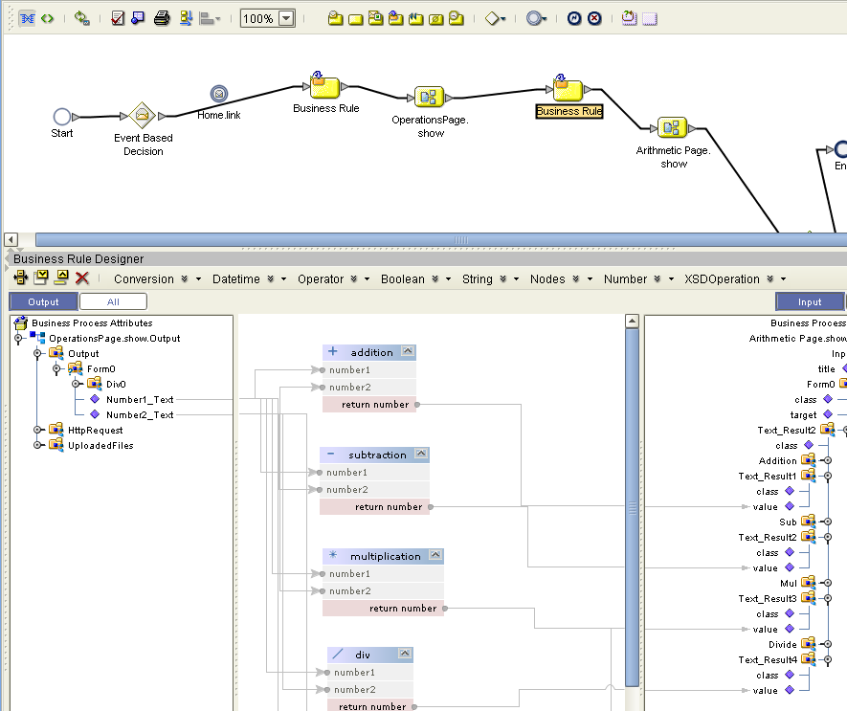

- Now link the ‘ArithmeticPage.show’ to the ‘Event Based Decision.End’ and from ‘Event Based Decision.End’ to ‘End’ button and save it.

Creation of a Connectivity Map
- Right click on ‘prjVISION’ project and select ‘NEW’ connectivity map and rename it to your choice.
- Now drag the PageFlow created above from the ‘Enterprise Explorer Window’ onto the canvas of the connectivity map.
- Now drag a ‘Web Connector’ component from the tool bar available on top of the connectivity map onto the canvas.
- Now connect the input (implemented services) and output (invoked services) of the PageFlow service to the ‘Web Connector’ created.
- Now add the below configuration parameters for the inbound eWay (cmVision_PFVision1 → eaWebConnector) and save it. ( Servlet Context Name – Any name of Your Choice , Authentication Method – FORM , Form Login Page – Login page you created , refer page 6 in this document )
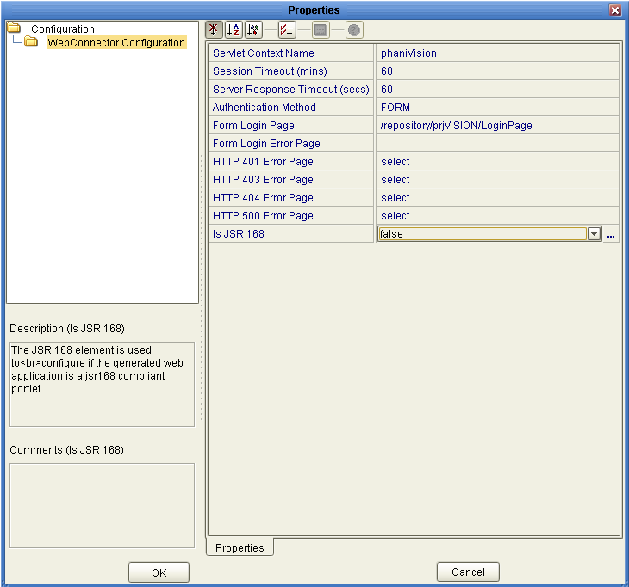
- The connectivity map will looks like below.
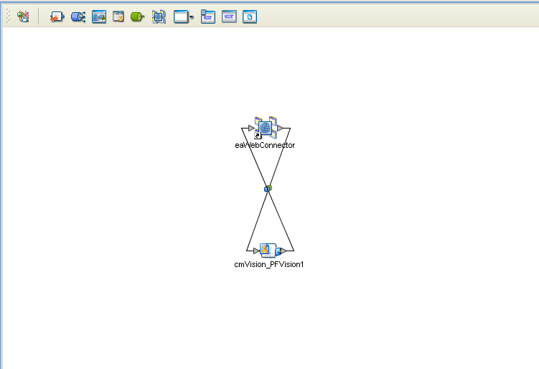

Adding a New eVISION external system in the environment
- Right click on your environment (Assumption – You have already created an environment in the Environment Explorer), select ‘NEW’ and select ‘eVISION External System’ and rename it to your choice.
- Right click the eVISION external system created now and click the properties option. Specify any name of your choice in the ‘User Role’ parameter of ‘Web Connector External System Configuration’ and save it.
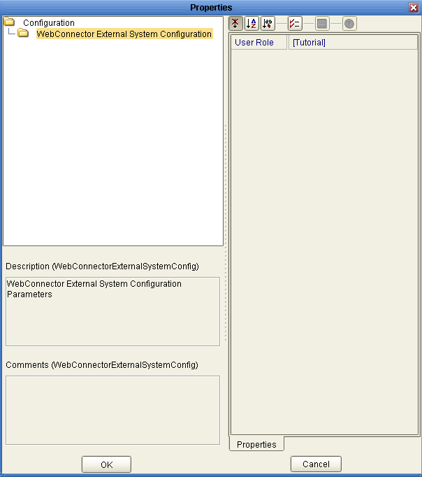

Managing login user in the integration server of the logical host
- Now login to Enterprise Manager(Assumption – Your logicalhost is running) and right click your logicalhost. Now click ‘Manage Integration Server Users’ from the menu.

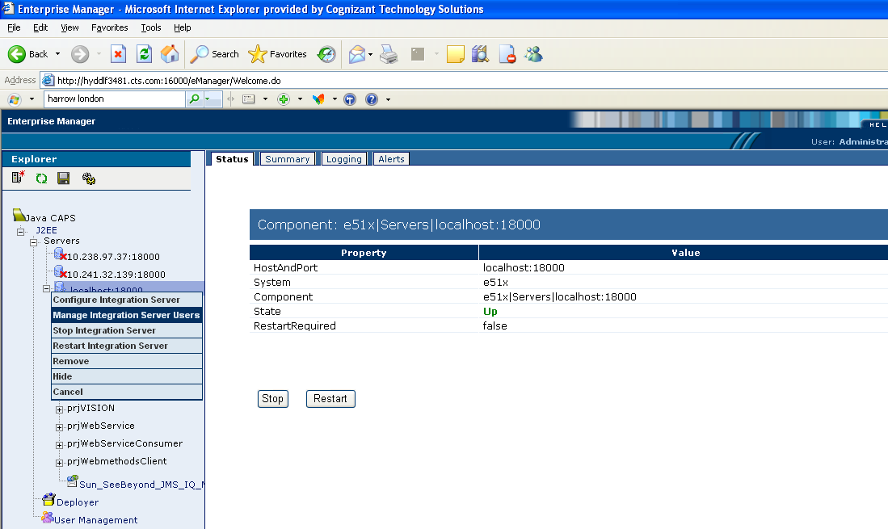

- The User Management portion of the Integration Server Administration tool appears. If the page is not displayed, then check for your proxy settings and disable them.
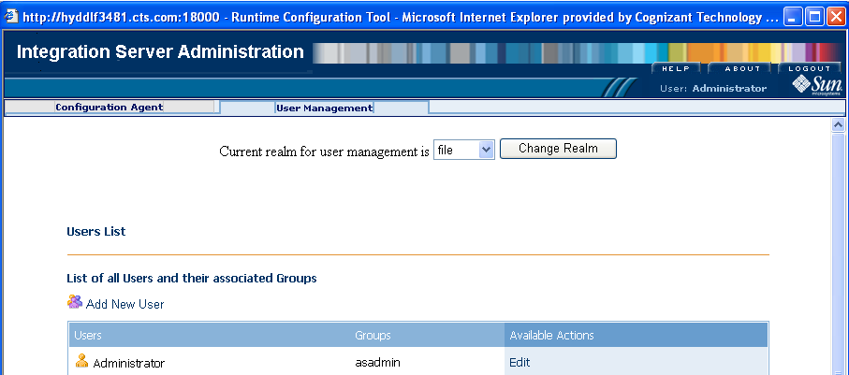

- Add a user by performing the following steps:
  - Click Add New User.
  - Enter information for the new user. In the Group List field, type Tutorial (Parameter you specified in the User Role field of eVISION external system in your environment – Refer Page 20 in this document).
  - Enter Password and click Submit and logout of the Integration Server Administration Tool.
- The final users list would be like the following.
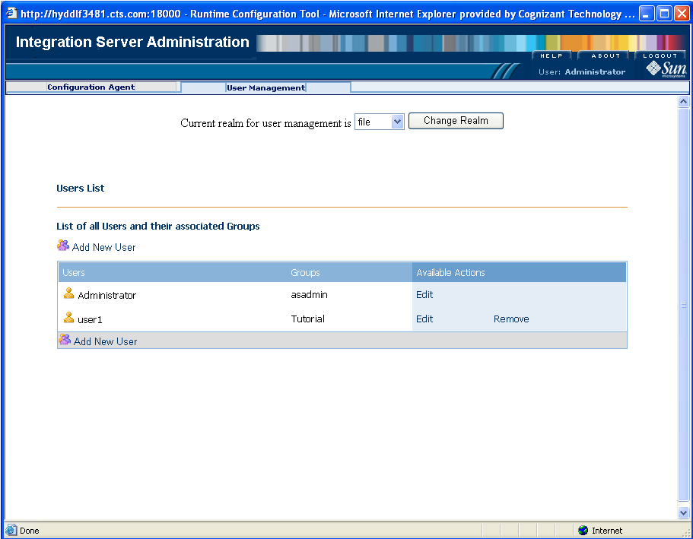
- Now restart your logicalhost again.

Creation of Deployment Profile
- Create a NEW deployment profile for your environment and click the ‘Automap’ option and save it.
- Now click the ‘Build’ button. Once the build was successful, then click the deploy button.

Executing the Web Page
- Start a Web browser and type in the following URL.
http:// [host on which the logicalhost is running -> ex: localhost]: [18001 –http port] / [Servlet Context Name specified in the connectivity map –refer page 18 in this document]
The URL will look like http://10.241.32.141:18001/phaniVision

Output Screen Shots
- Login Form
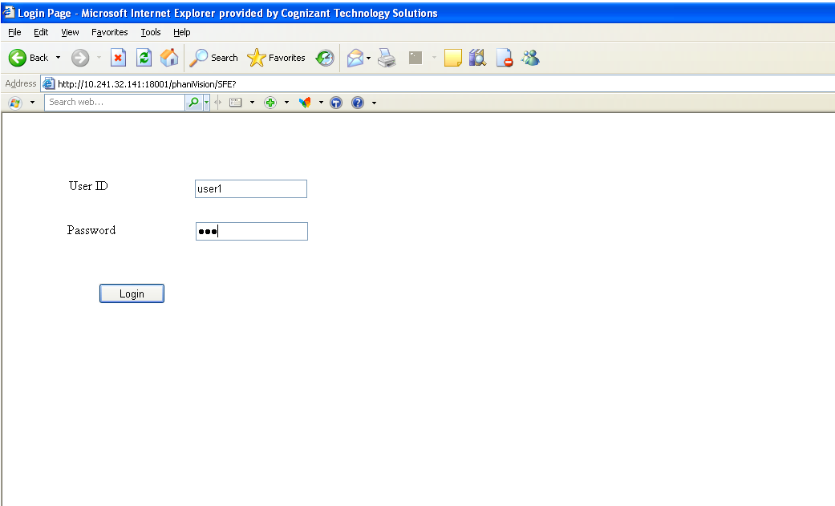

- Operations Page
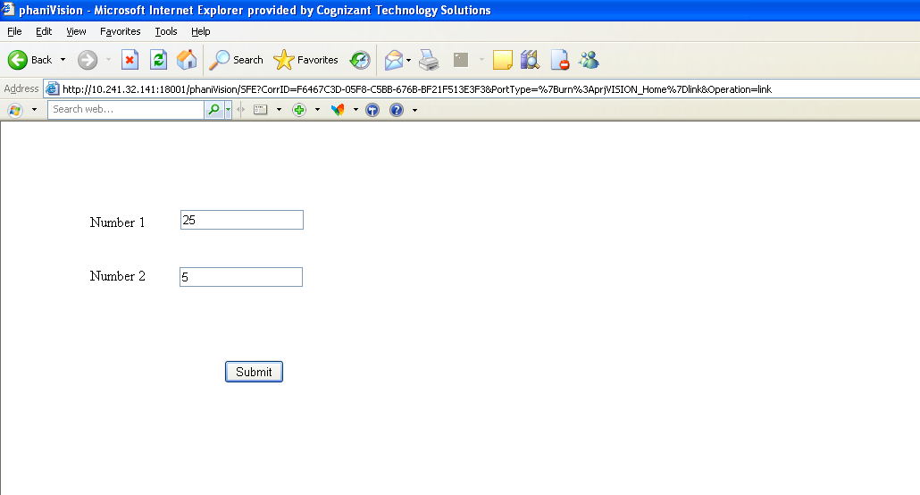
- Arithmetic Page
